Devan gaddi

CIS233DA

5/29/23

Before you come to class

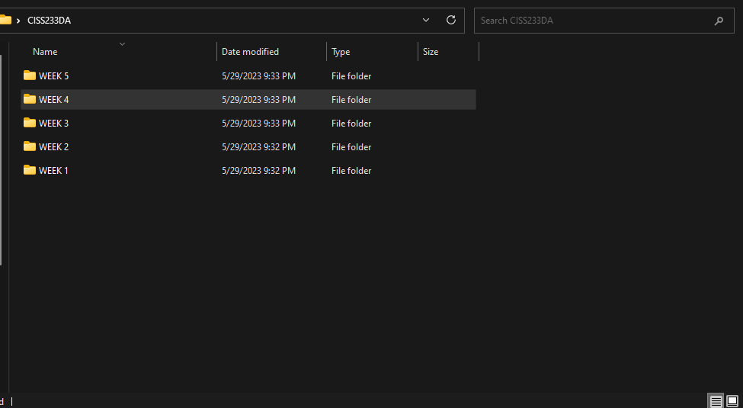

https://github.com/devanohdevan/CIS233DA.git